**Team ID :** PNT2022TMID18613

**College Name :** Sona College of Technology

**Department :** Computer Science And Engineering

**Project Name :** Customer Care Registry

**Team Leader :** Viruchith GA (1919102189)

**Team Member :** Srivignesh S (1919102161)

**Team Member :** Shrishtidharan KA (1919102149)

**Team Member :** Venkatesh S (1919102712)

**Introduction :**

Customer care is more than just providing great customer service. It’s a proactive approach to providing information, tools, and services to customers at each point they interact with a brand.

High-quality customer care is proactive. The needs of customers throughout the buyer’s journey are anticipated, making customers feel supported. That, in turn, helps create an emotional connection between the customer and the company. Customer service is reactive. Here, the focus is on helping customers solve problems or answer questions before purchase, either in a self-serve fashion or via the customer support team. If a company neglects customer care, it can negatively impact the customer service experience. For example, when a website chatbot can’t provide key information about a product, customers are more likely to get frustrated and reach out to a customer service agent for help. This places a greater burden on the support team to quickly address the issue and mitigate any effects of the negative experience. To achieve the best customer service, your customer service team should address customer needs quickly and with as few customer interactions as possible. According to McKinsey executives for too long focused on improving specific touchpoints, overlooking the needs of the entire customer. McKinsey notes that as customer expectations evolve, companies must consider the customer experience from the first website visit to troubleshooting issues with a purchase.

**Existing and Proposed System :**

Compared to this proposed system, in the present system all the features are performed either manually or with the help of word processor. While providing services to its customers, the present computer service centers generally keep the details of the customers and products in word documents, spreadsheets or paper register, and the management of all records is illegal to some extent.

There are problems relating redundancy of data like customer name and address, details of their account and also allocation of duties to the employees. When a customer takes some kind of services, the charge is calculated manually, and this process is time consuming. Also, regular and overtime duties are not maintained properly. This leads to improper calculation of employees payroll and calculation becomes quite complicated for every employee.

Another problem usually faced by the organization which has been solved in the proposed Online Customer Care and Service Center Project is the frequent complaints by the customers for not getting timely services. This is due to the improper working schedule of employees and the method for keeping the records.

Here, the owner has to keep a watch on everything of their service center at all times. In this case, it is nearly impossible to get the details and records of the status of services when required. All this makes the owner the key person to handle the whole working system, and henceforth the workload is not shared by equally amongst the people running the service center.

In the present system, there are no facilities to properly handle the human resources such as staff information, their attendance and monthly salary records, account handling, customer details, etc.

Now, in this proposed system of Online Customer Care and Service Center Project, there will be a standalone Personal Computer with the required application. And with minor modifications in software, it can also run in network. There is no significant difference between the current system and the proposed design of the system.

**Study Design :**

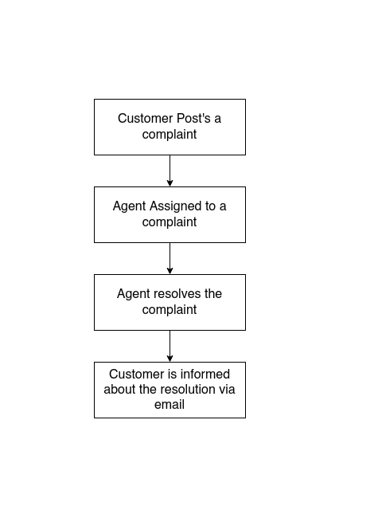

**Conclusion :**

Consumer expectations are extremely high, putting increased pressure on companies to improve their customer relationships. According to Forrester only 18% of customers said they would continue doing business with a brand that has disappointed them. In addition, poor customer care is costly. That same Forrester report showed that ecommerce retailers suffer, on average, USD 22 million in unnecessary service costs due to channel escalation. Adding to this pressure is the number of customer service channels today. Social media, email, call centers, chatbots, and text add numerous touchpoints and complexity to customer service operations. This can lead to lost information when the same person reaches out via multiple channels. When a customer service agent doesn’t know the whole story and the customer has to repeatedly share the problem, it leaves both people frustrated. Call centers and direct customer service agent interactions are still vital to any customer service department, but they are costly to run and can have a high rate of employee turnover. Chatbots, social media messaging, and other self-serve options have drawbacks as well, despite their convenience, including slow response time and inaccurate, irrelevant answers that require the customer to escalate the conversation to another channel.